33.53: a) The time taken to travel from point A to point B is just:
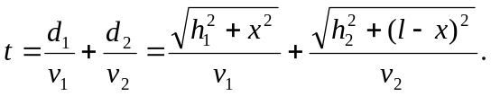
Taking the derivative with respect to x of the time and setting it to zero yields:
